**Rakshitha.M**

**1RVU22BSC079**

**Activity 2**

1. In this task, a simple registration form is created in an Android application, including input fields for a username, password, email, and phone number.
2. Variables are declared for the Edit Text components (text fields for username, password, email, and phone number) and Buttons (for submission and cancellation).
3. The XML layout defines the structure of the registration form, containing fields for the username, password, email, and phone number, along with "Submit" and "Cancel" buttons. The "Submit" button allows users to send the form, while the "Cancel" button clears the inputs. All sections are appropriately labelled, and input types are set to ensure correct data entry.

**XML Code:**

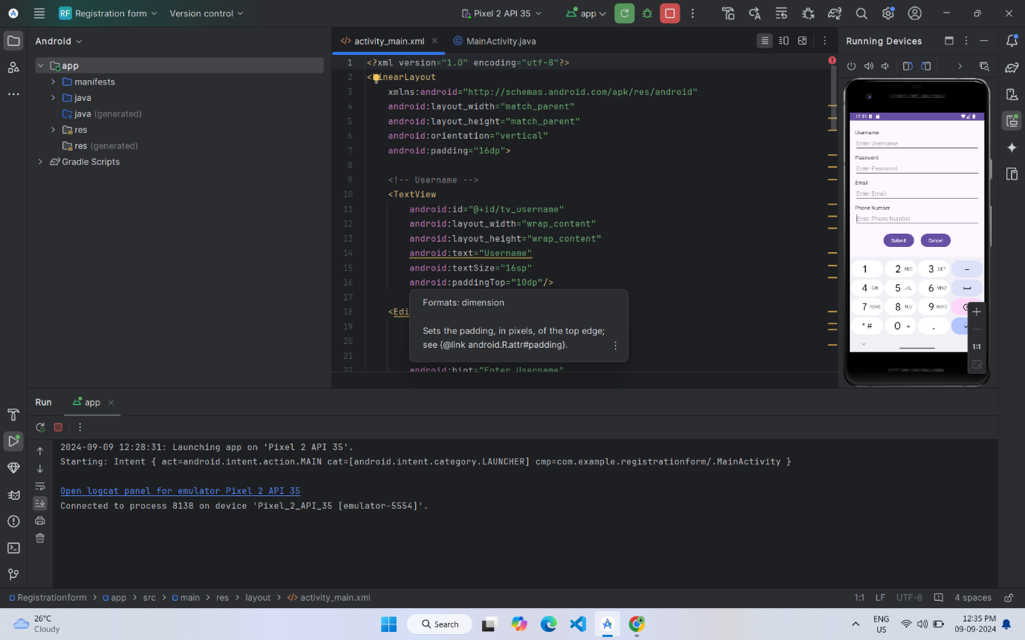

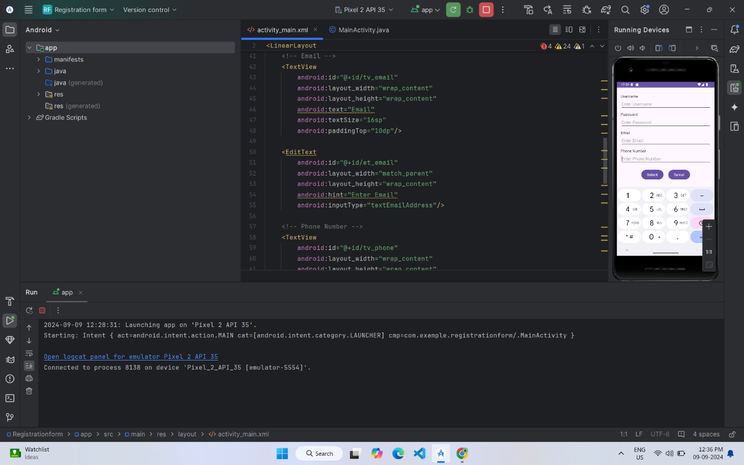

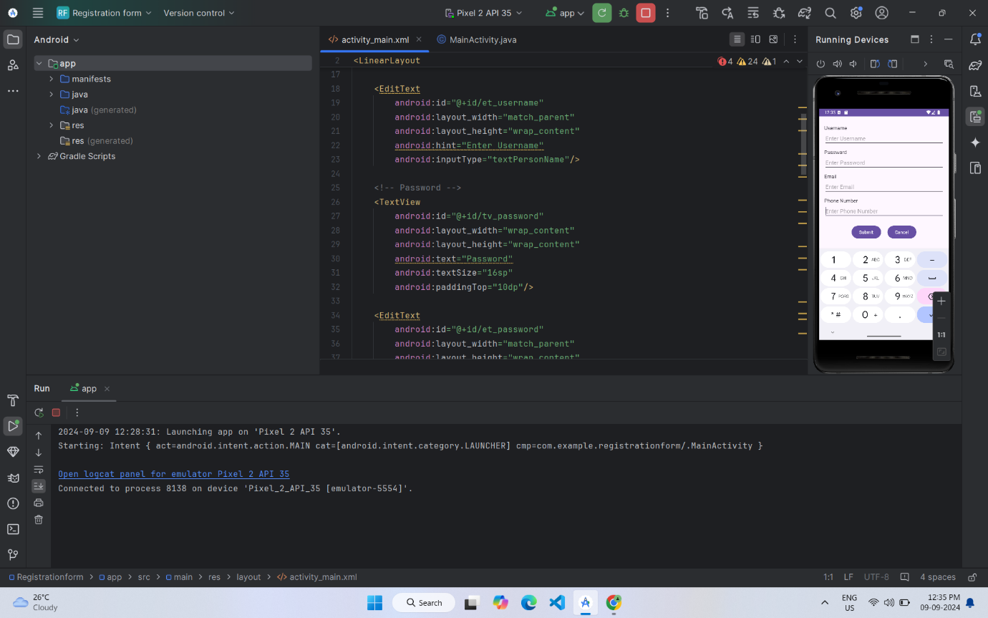

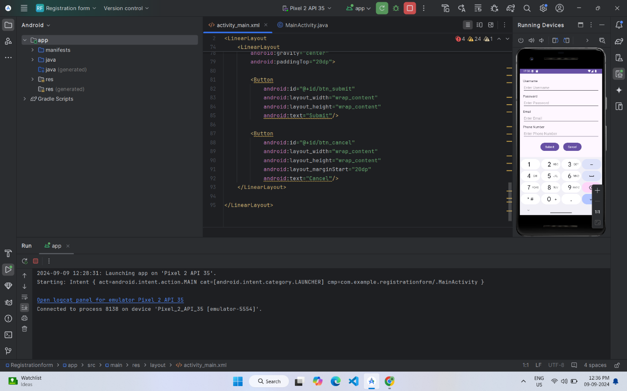

**Java Code:**

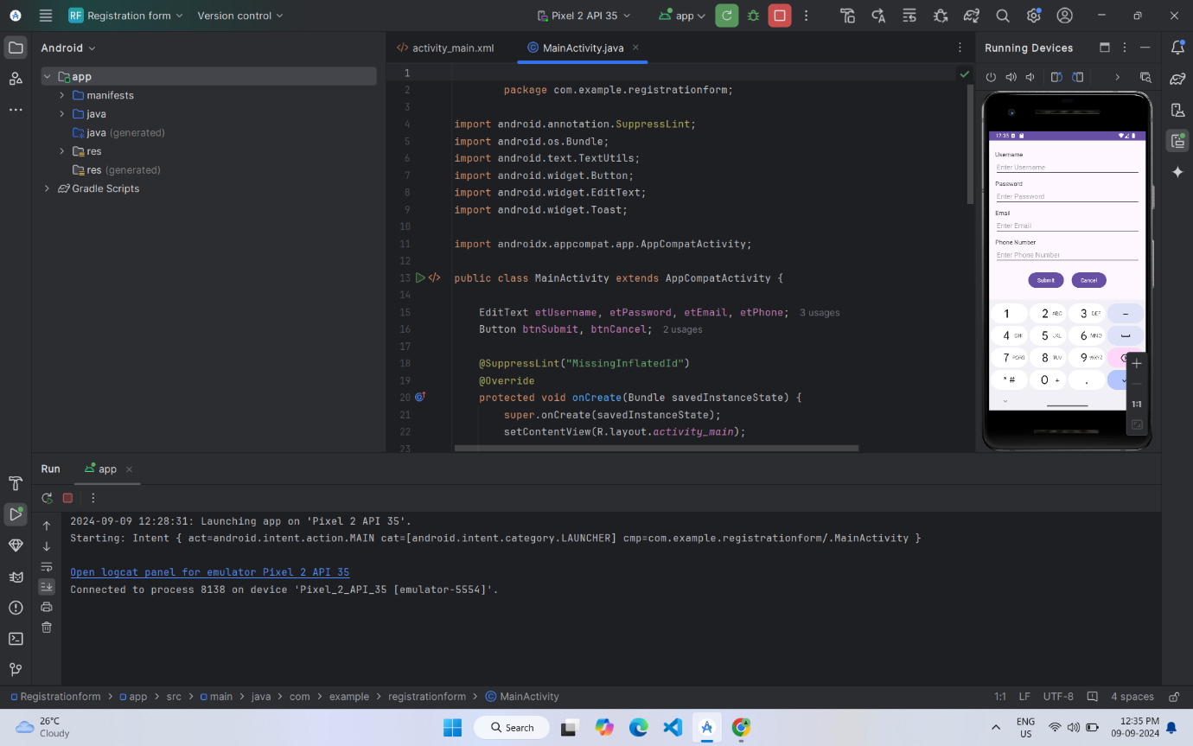

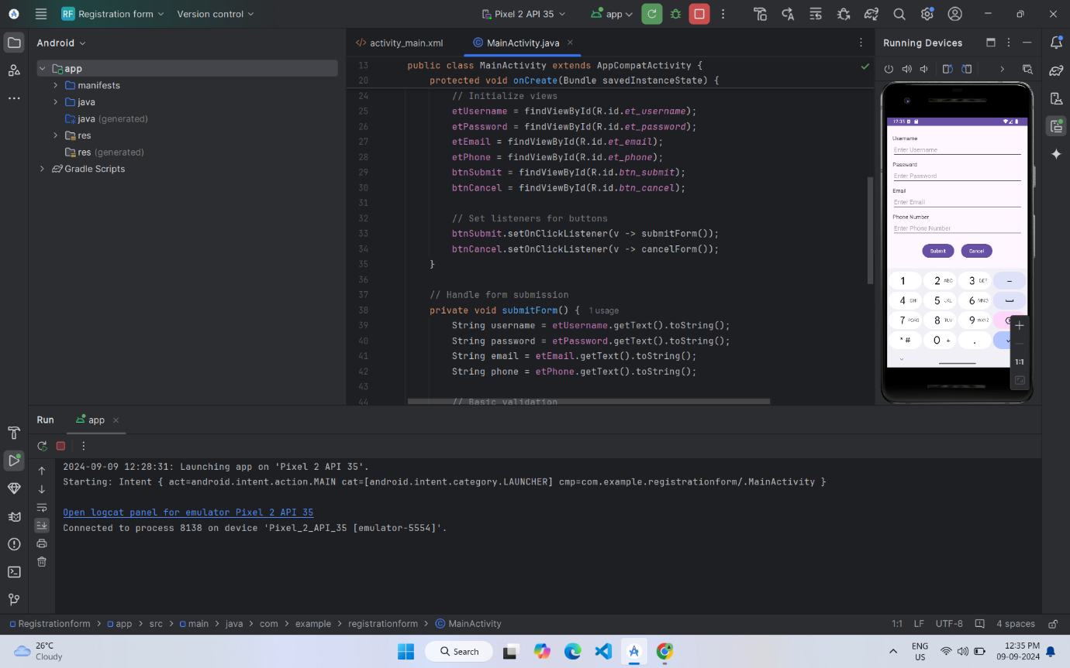

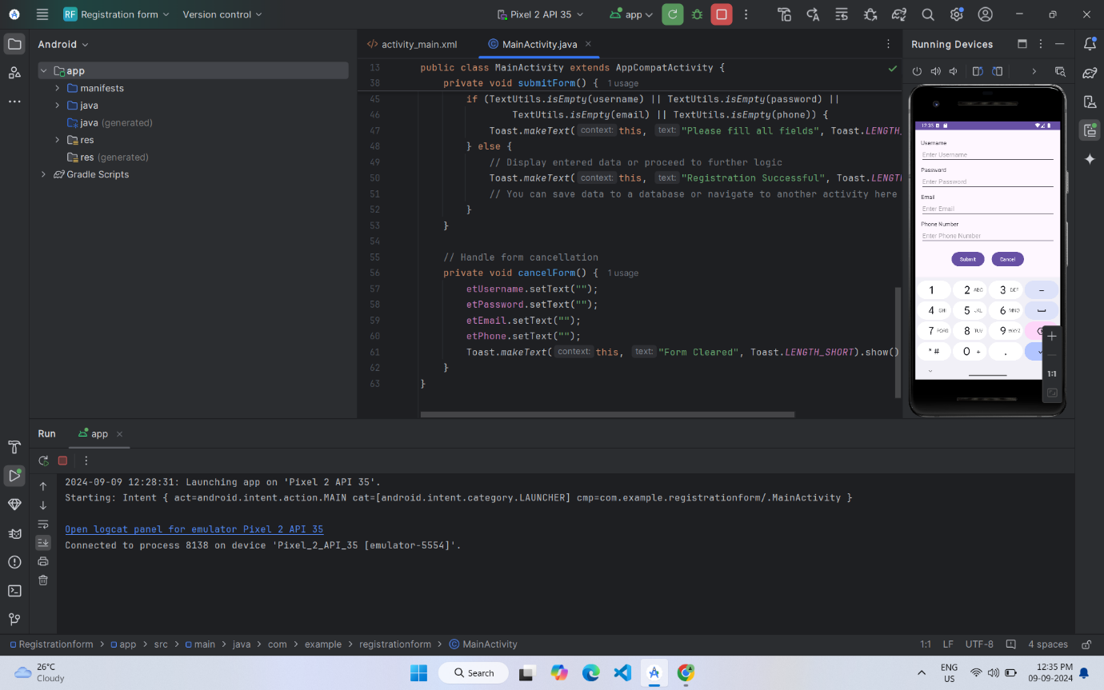

**Output:**

